As a student at Union College, I am part of a community that values intellectual effort, curiosity and discovery. I understand that in order to truly claim my educational and academic achievements, I am obligated to act with academic integrity. Therefore, I affirm that I carried out the work on this exam with full academic honesty, and I rely on my fellow students to do the same.

For this Exam, I understand that:

1. I **must** work alone in writing out the solutions to the problems in this exam.
2. I **cannot** copy solutions, in part or whole, to the problem on this exam from any person or resource.
3. I **cannot** use any electronic resources to assist me in the solution to the questions on this exam except for my calculator to only performing appropriate calculations on the exam.
4. I **can** use one page - single sided - of notes during the exam. This one page of notes **cannot** contain any solutions to problems. **I must staple this page to the back of my exam at the end of the exam**.

Signature:

Print Name:

Exam Date:

**PROBLEM 1:** A horizontal beam AB is supported by a pinned-end column CD, as shown in the figure. The column CD is a solid steel bar (E=200 GPa) of square cross section having length 1.8m and side dimensions b=50mm ().

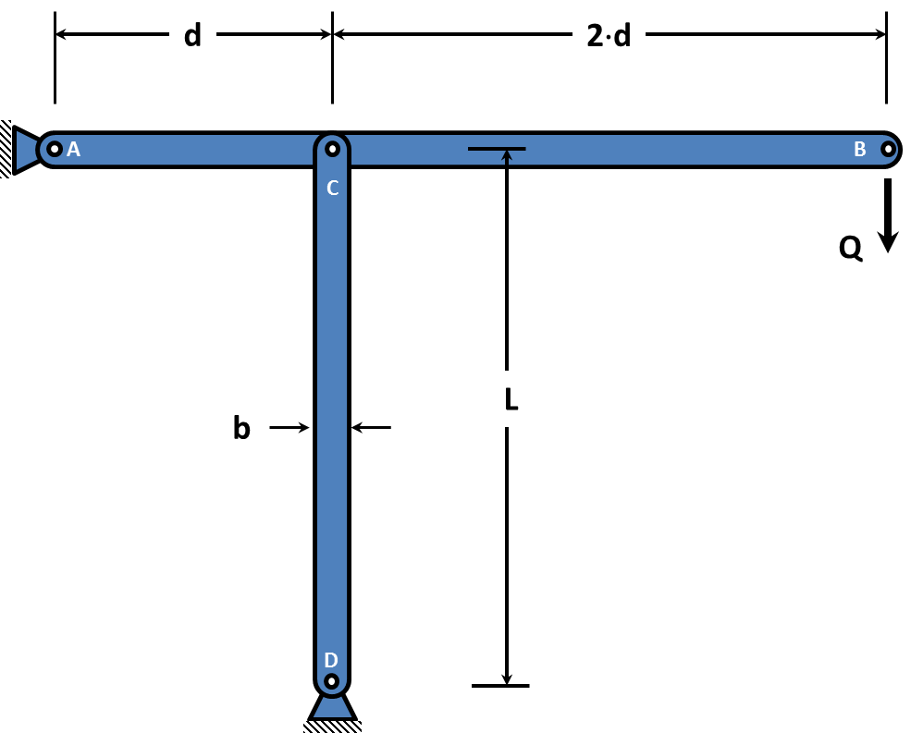

**1a.** Using the freebody diagram below, determine the load in member CD.

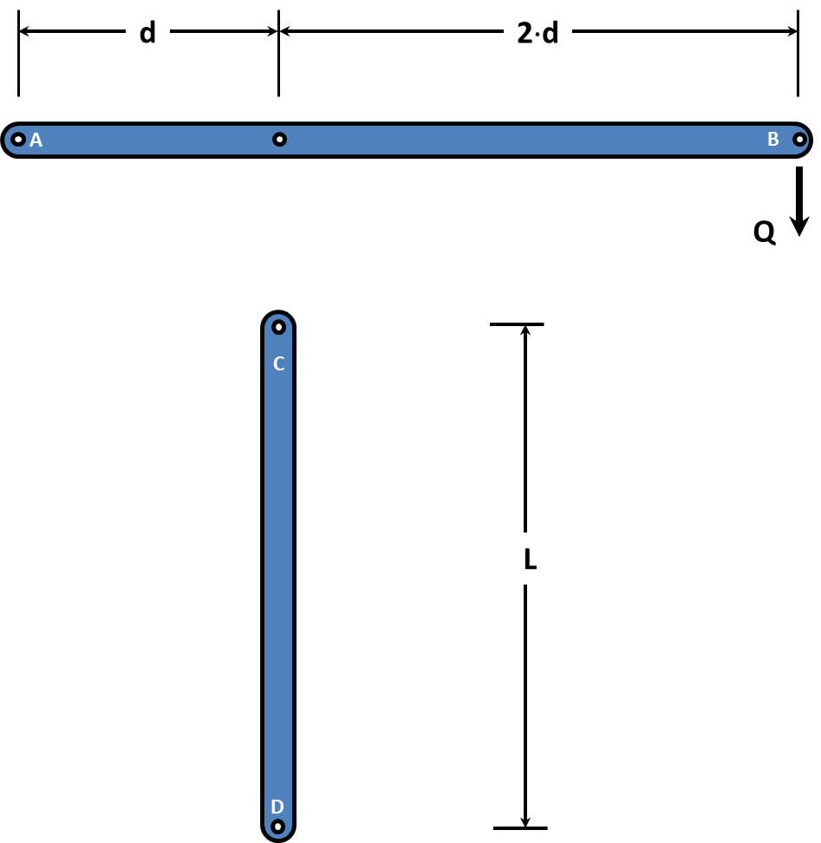

**1b.** Based upon the critical load of the column, determine the allowable load Q with respect to buckling.

**PROBLEM 2:** Below is a ½-in pitch roller chain plate, as used on a bicycle chain. Since a roller chain cannot transmit compression, the link is loaded in repeated axial tension (load fluctuates between 0 and a maximum force as the link goes from the slack side to the tight side of the chain) by pins that go through the two holes shown.

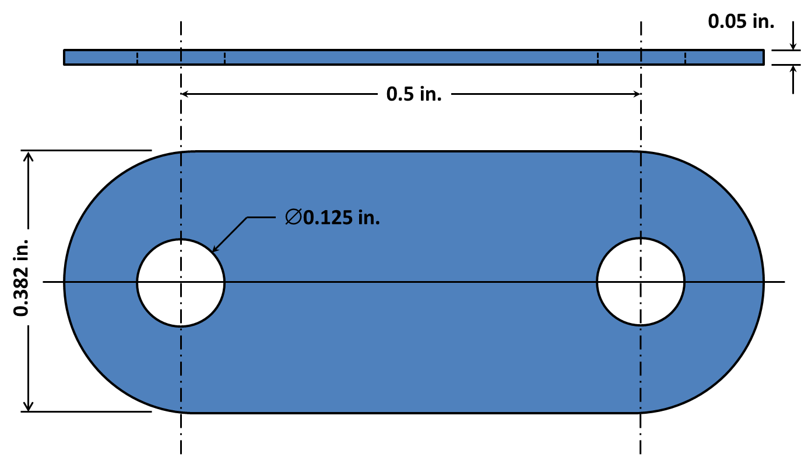

**2a:** Using the graph paper on the next page, draw the Modified Goodman diagram for this problem. The link is made of carbon steel, heat-treated to give Su=140 ksi and Sy=110 ksi. All surfaces are comparable to the “machined” category. Use the conservative estimate of Notch Sensitivity q=1.0.

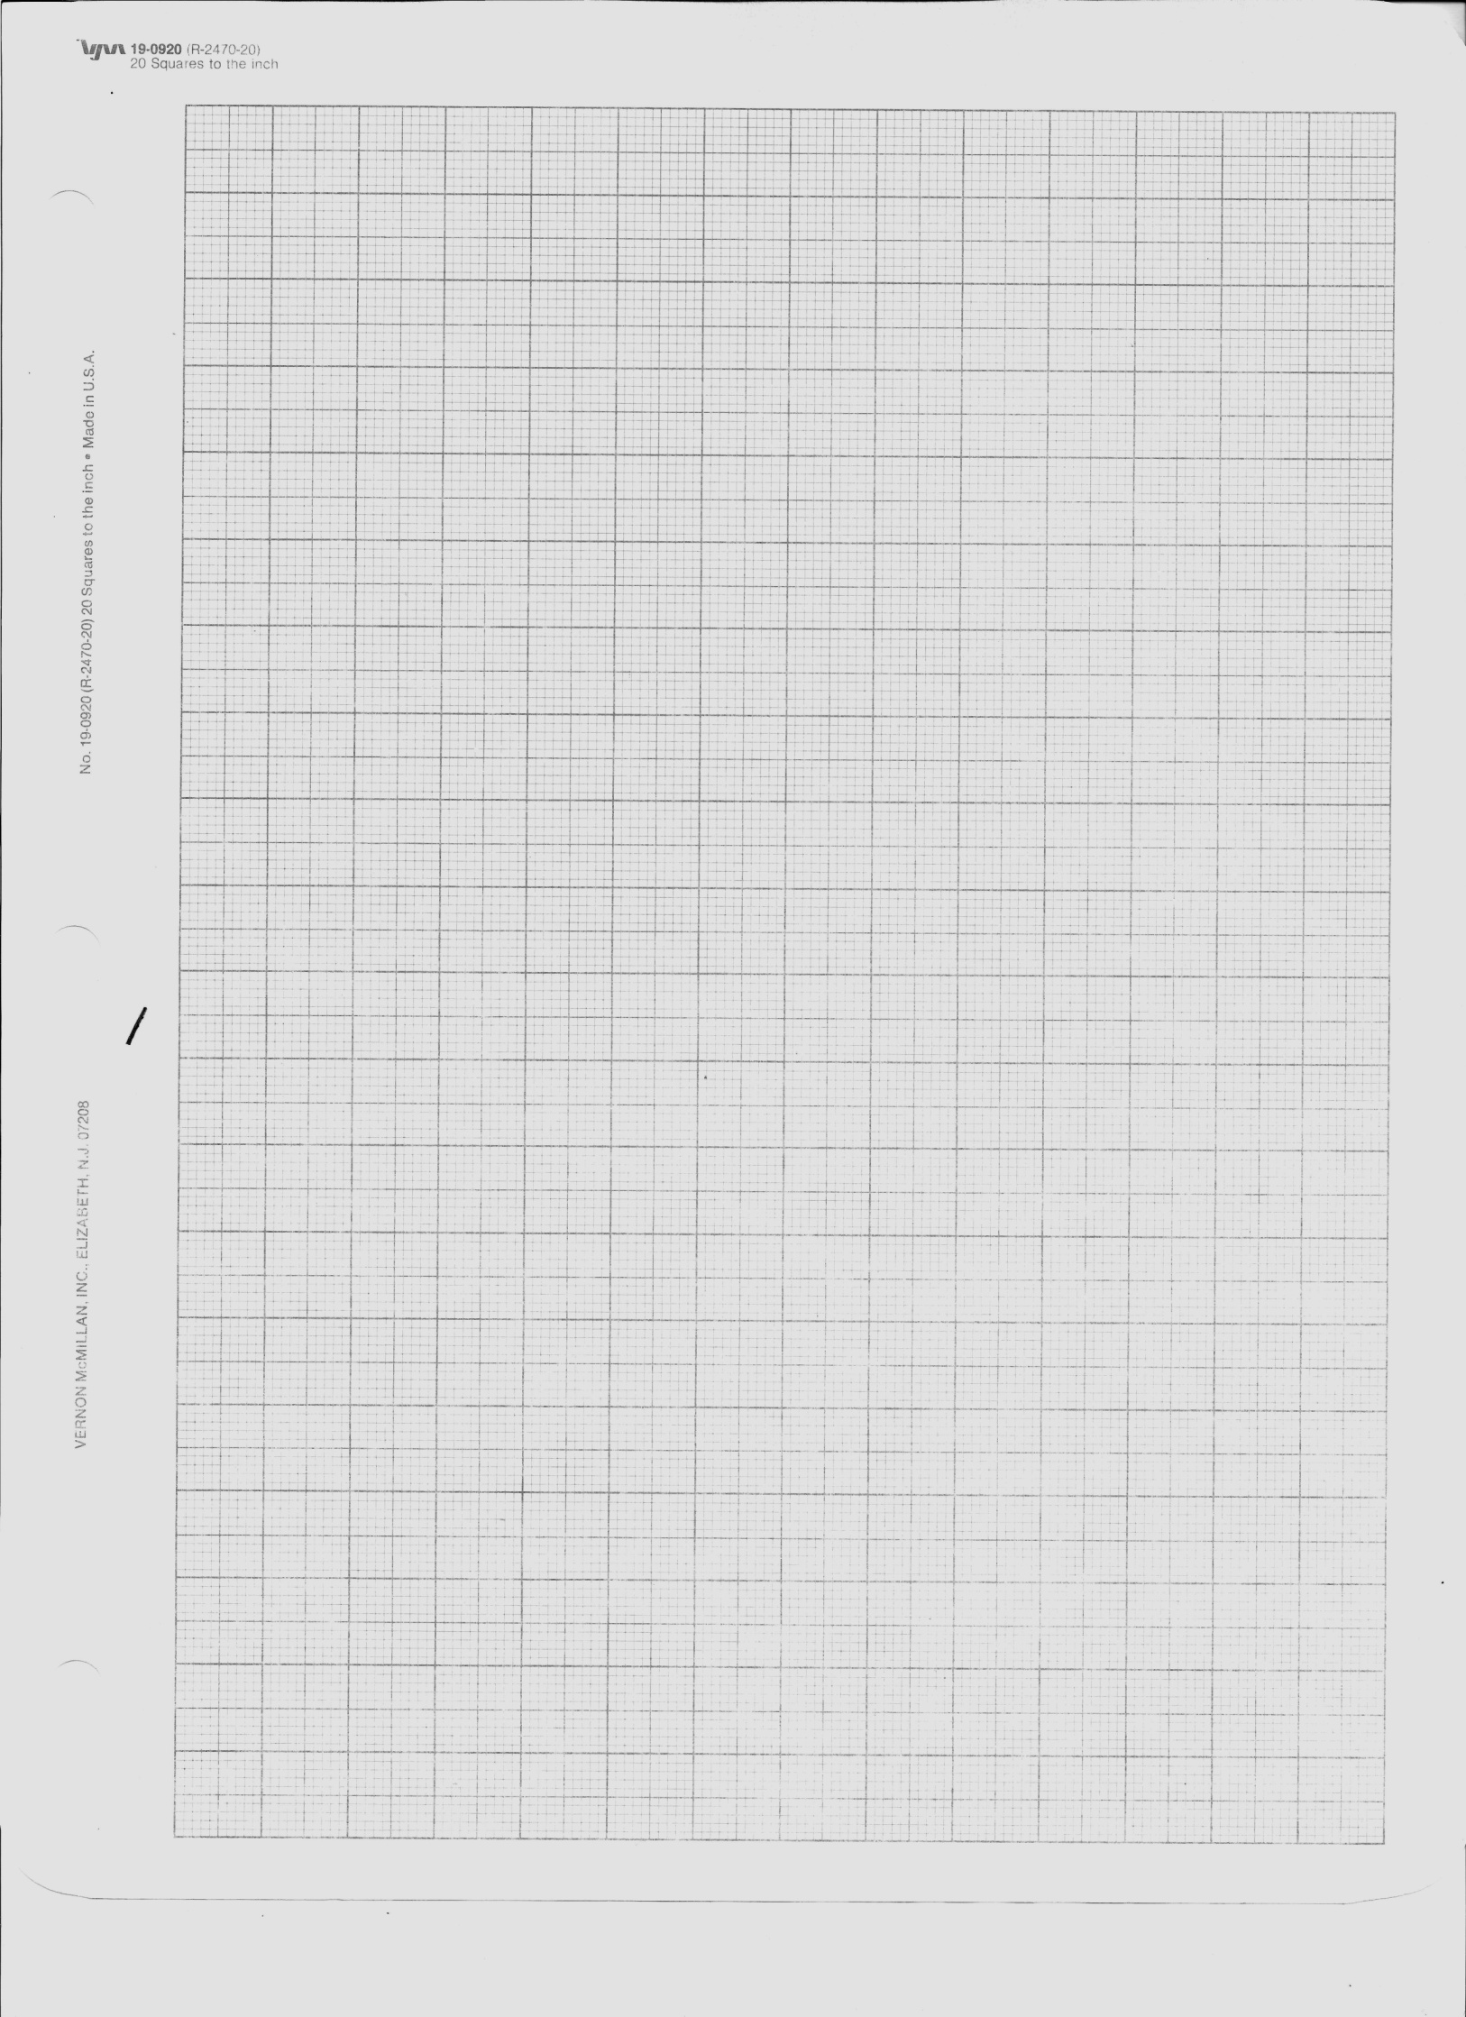

**2b.** Estimate the maximum tensile force to prevent yielding for static loading and the maximum tensile force for a static factor of safety of 2.

**2c.** Estimate the maximum tensile force that will give infinite fatigue life. Draw the fatigue stresses on the Modified Goodman Diagram in part 2a. What is the tensile force for a fatigue factor of safety of 1.2?

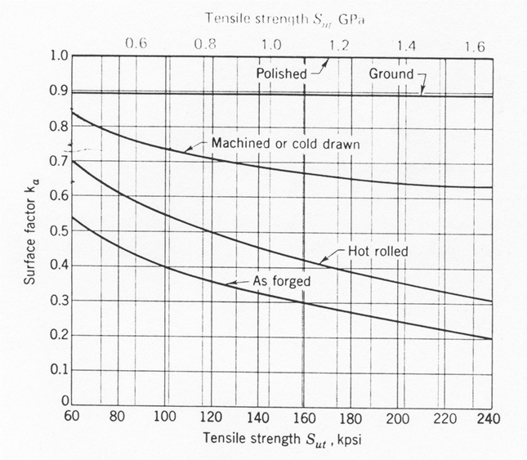

**Fatigue Surface Finish Factor Chart**

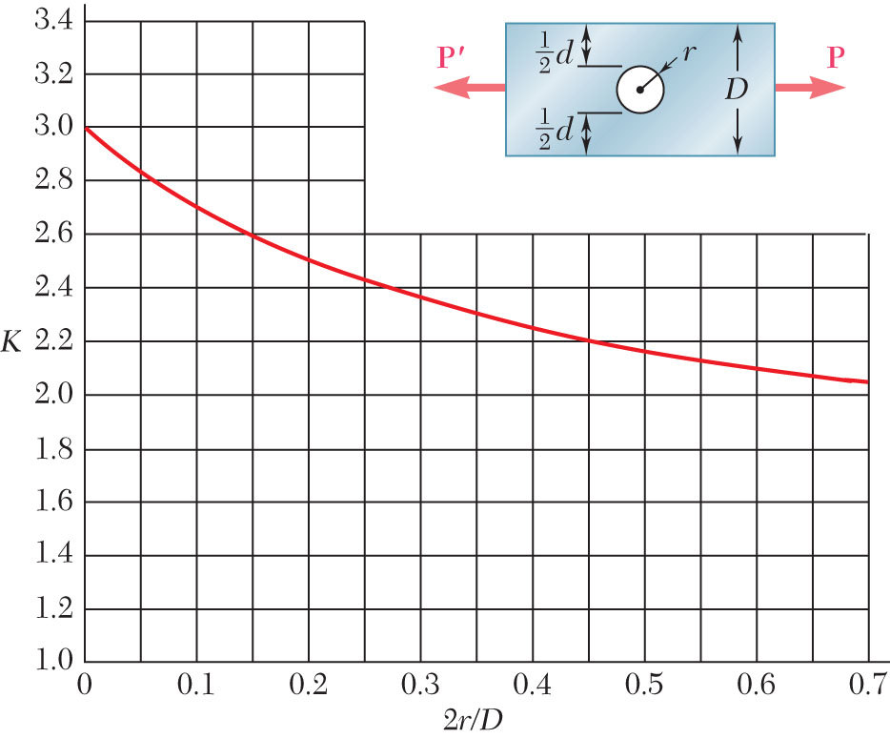

**Static Stress Concentration Factor**